Jane Turner, Jen Seevinck, Marcus Foth, Keith Armstrong, Nicole Vickery, Nick Kelly, Anastasia Tyurina, Heather McKinnon, Amari Low, Lowana Davies
More-than-Human Futures, Design Lab, School of Design, Queensland University of Technology

Kinning with the Unseen More-than-Human: Towards methodologies for the Barrambin Project

Keywords: Kinning, More-than-Human, Place, Relational ontologies/methodologies

Introduction
This paper describes our approach to revealing and reconnecting with the hidden habitats, More-than-Human inhabitants, and latent significance of a Brisbane waterway. It is centred upon a place known as Barrambin or “the Windy Place”, an area that is currently (and always has been) a cultural site for the Turrbal and Yuggera First Nations People. It is also an urban residential village, adjacent to a university teaching campus.

Prior to colonisation, Barrambin was a grove rich in fresh water, with a billabong, pools and small creeks leading down to wetlands and the Brisbane River. As a pathway to the river, the area was culturally significant and a site of gatherings and corroborees. The presence of fresh water coming down from the hills into the river also meant the site was an enticing area for early European occupation and its proximity to the city and river meant it was quickly urbanised. The numerous creeks and connected pools and water courses were forced into ditches and drainage systems, rendering them largely invisible to the casual passer-by.
Recent flooding events have demonstrated, however, that the original waterways have not vanished (see Figure 1). Their traces still exist and serve an important role for many human and More-than-Human beings in the area, with the waterways reappearing in times of significant rainfall. Some open space has been maintained in the Barrambin area, which has been used over decades as a quarry, a rifle range and military encampment, and a municipal golf course. When the residential village was built in 2003, the park remained fenced off as a golf course and the village was oriented to the university campus, effectively turning its back on the waterway and parklands. The golf course was repurposed back to public parklands in 2021, creating an opportunity to reconnect the Kelvin Grove village area with the ancient waterways and open spaces.
Figure 1: Mostly hidden in plain view, the waterways (blue) and wetlands (green) in Barrambin have been identified here by authors – annotated over base map data (copyrighted OpenStreetMap contributors, https://www.openstreetmap.org)
This paper describes The Barrambin Project which seeks to create connections between waterways, place, and community through the related methods of kinning and narrative inquiry. The project is framed by a More-than-Human theoretical lens that eschews the universalism described by Haraway (1991) as a view from nowhere, in favour of approaches that de-center (Forlano 2016) the human exceptionalism of the universal perspective and recognise and embrace multiple forms, hybridities and multiplicities, and more nuanced understandings of heterogeneity. Thus, the project began as an effort to draw attention and give voice to those ancient waterways, creeks and connected pools of Barrambin that remain important to life in the area.

As such, we seek to create a relationship – kinning – with these seemingly disappeared and concealed (unseen) waterways. This offers a situated community engagement opportunity, a playful way to re-make old pathways for people to walk from the centre of the village through to the newly-opened parklands of Barrambin’s ancient gathering place, and a means to engage in what Donna Haraway (2015) calls the “ethical responsibility” of making kin with the More-than-Human world, arguing that kinning is about accountabilities and responsibilities.

This design-led project seeks to unveil this relationship – to re-kin with, and reveal, the unseen and long-forgotten, in order to initiate a design response. While the project is in its early days, the general hope of the research team is something participatory that would involve the local community. This is where we found ourselves questioning how wide the concept of community might be, and whether it might include the More-than-Human in the form of the Barrambin waterways. It has been a complex process and we found it necessitated developing embodied and reflexive understandings of Barrambin and connection with the personage of the Barrambin waterways. Here we describe one set of understandings of that personage and consider a key dilemma that can arise when endeavouring to include the More-than-Human. Images from Barrambin illustrate a narrative and embodied understanding of the now-unseen waterways, while also providing more opportunities for other interpretations, keeping the story open, more plural and “multiplicitous” and leading us to reflect on how we might involve the urban village communities in the process in a resonant way – one that engages with the unseen waterway and adds to its multiplicities. First, however, we briefly review the theoretical and methodological framings that have guided us in this approach.

Designing with the More-than-Human: Kinning
“Designing with” is urgently necessary in the call of More-than-Human design research. Design research scholars have a long history of engaging with issues and concerns around environmental sustainability and climate change (DiSalvo, Sengers and Brynjarsdóttir 2010; Paulos et al. 2008; Foth et al. 2008). Early work often borrowed from behavioural psychology and largely sought to change consumer behaviours towards more environmentally friendly choices, such as conserving energy, avoiding single-use plastic products, and increasing overall resource efficiencies. However, the underlying focus on usability and thus “the user” mostly remained unchanged. The strong focus on the user has not only been criticised for its singularity but also for its human exceptionalism. The same focus is additionally problematised in decolonial perspectives for its deep systemic bias in favour of western onto-epistemic systems (Haraway 1991; Tuhiwai Smith 1999).

A key development in this context has been the emergence of design work best characterised as “More-than-Human” (DiSalvo and Lukens 2011; Forlano 2016; Giaccardi and Redström 2020). This decentres the human and proposes new methods for life-centred design that engages and “designs with” the More-than-Human world (Akama, Light and Kamihira 2020; Clarke et al. 2019; Forlano 2017; Tomitsch et al. 2021). This approach can leverage the inherent democracy of the participatory design approaches that feature in many ethical design projects today, extending them beyond the human world and the implicit accompanying biases. Designing with the More-than-Human challenges us to examine the ways we enact designing and invites us to create new approaches and methodologies.
Interrelated to More-than-Human methodological approaches is the idea of kinning. Asserted by Haraway as a crucial step in addressing the growing crisis of species refugia and our collective survival, kinning involves reframing our understanding of relations across species and actively pursuing those relations to “...make-with – become-with, compose with – the earth-bound” (2016, p. 102). If we accept Haraway’s position that kinning is about accountabilities and responsibilities, we also must recognize that it is an active, intentional process that we seek to cultivate through our actions as researchers. This in turn is based upon an ongoing questioning of what it means to live within a world populated by many, many others who are just as much subjects and as central to that world as we are. The act of kinning requires us to continually ask questions around how we might better relate to the world beyond the human world, in ways that are just and ethical. As a practice it is therefore both actively relational and always in process. Kinning provides a theoretical framework to pursue social and sustainable design intervention that highlights a more pluralistic approach to being inclusive of the More-than-Human. This is especially important when we consider More-than-Human multiplicities such as Country, described by Rose (1996) as feeling and knowing. Even more so when we consider the connection to waterways and rivers in Indigenous identity, a connection described by Morris and Ruru (2010) with a Māori saying: I am the river and the river is me.
Our design research process brings these sympathetic concepts – designing with and kinning – together, alongside historical waterway data and a sensitivity to Indigenous understandings of Barrambin. Specifically, we have been looking for ways to relate – kinning with – these seemingly disappeared waterways. This has necessitated reflexive considerations and we have found it deeply problematic: we must continually ask ourselves how we might find an appropriate methodology to reflect others’ voices. We respond to the challenge that Clarke et al. (2019, 61) raise when they ask “…how do we make the experiences of non-human others palpable? How do we hear, and how do we encourage others to hear, the non-human voices?” And, as Barrambin involves a combination of human systems, More-than-Human ecological systems, and multiplicities of participating actors (plants, animals, birds, even the landscape) – the idea of kinning becomes even more complex and challenging.
In order to find ways to acknowledge this multiplicitous complexity, we have been developing an embodied understanding of Barrambin: walking the country as an essential aspect of the knowing and understanding, and as a way to guide poetic, analytical and narrative interpretations. The result is a reflexive account of these meanderings. It seeks to capture some of the multiple facets of the Barrambin personage: from present to the past, hidden to implied to visible. Presented in this paper is a particular reframing, just one story of a potential method that arises in our exploration of potential methods that might work within the auspices of our hoped-for methodologies. This approach is not without tension. Out of a desire, following Graham (2009), to understand knowledge as rooted in place, kinning, design and narrative inquiry methods, we sought out stories that all originate with this Place of the Barrambin waterways: stories from the More-than-Human as well as the human, the scientific as well as the metaphysical. The paper documents our ongoing effort to listen for, seek out, understand, and share such stories as an active process of kinning and a prelude to any design work that might connect the community back to the parklands and the grove area.

A first step is to ask who we are re-connecting the community with?

Who is Barrambin?
“The river came first, long before humans occupied its banks,” says Margaret Cook (2019, 1) about the Brisbane River, echoing Mary Graham’s (2009) discussion of the primacy and influence of Place as context and co-relational partner in meaning-making and the way we understand and make sense of our lives and the world. The river shapes the land that gives the area its Indigenous name of Meanjin ,meaning ”spike”. It shapes the city of Brisbane, rising in the ranges west of us, fed by creeks and joined by other smaller rivers and seasonal creeks as it makes its way down in lazy loops and curves across the plain, meeting the sea in the calm waters of Moreton Bay, sheltered from the Pacific swells by large sand islands. For local Indigenous communities, the creeks, and the valleys they create, carry stories of their places and histories and are sites of food, water, and corroborees. The waters of the Windy Place are a part of the river system but also a system set within the valleys and groves of the lower hills of Mount Coot-Tha and beyond. The waters that contribute to Barrambin can only be understood as a multiplicity of pools, creeks, and contexts that the waters inhabit and move through (beds, banks, culverts), and the flora and fauna (trees, bushes, grasses, birds, fish, insects) that contribute to its “lifeness”. In this way Barrambin epitomises Place, the living entity that feels and knows (Rose 1996), which is entangled in meaning-making as a storyteller in its own right (Graham 2009).

Colonial occupiers report the potential of the Brisbane River as an access route to rich resources inland and the availability of fresh-water springs and pools in the creeks that run down the valleys and groves created by spurs of the smaller hills and higher ranges. The loops of the river in its floodplain meant availability of rich farming land – and the floods that created them. Over the years since colonisation and the establishment of the early settlement on the northern banks of the river, it has been heavily curated, embanked, dredged, and generally corseted (see Figure 2). This is no less true of Barrambin waters that feed into the river.
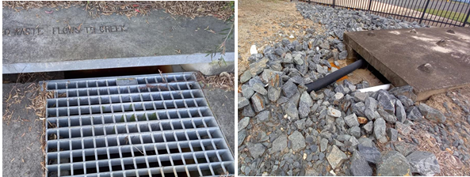
Figure 2: A walk along the bottom of the grove and line of old pools and creeks reveals waterways constrained to drains and underground pipes - examples of how the Barrambin waterways have been diverted and disappeared below the surface. http://www.barrambin-project.au/gallery/#bwg2/29

The river’s presence creates the history and the experience of the contemporary city. Living in Brisbane, an awareness and appreciation of its waterways is essential. The significant and historic flood events in 1974, 2011, and 2022 have shown the impact that the waterways can have on the city and are now part of the city’s stories and the place-making of the contemporary human inhabitants. Many of the numerous small creeks that feed into the river are hidden by infrastructure, directed via pipelines under roadways or corralled in occasional flood mitigation dells in parks and swales running alongside roads. Even a heavy downpour sees the emergence of water from the numerous drains with their warnings of “Flows to creek”. In this way, the river is an invisible co-creator of contextual meaning-making, but its voice and its stories are warped. The nurturing presence of Maiwar (Brisbane River) for the Indigenous peoples of the area is now an erratically angry resource of great value, appreciated for its beauty when it is quiet and acquiescent, worth much to the purveyors of waterfront luxury homes, but also feared and denigrated when its multiple identities are revealed. This is our central character in this research, a personage that exists as an ecosystem encompassing and supporting multiple other ecosystems from the trees, shrubs, groundcovers and vines to the creatures such as bats, possums, and birds that live in the trees alongside the aquatic creatures of the waters.
Beyond the wider river system with its flora and fauna and its creeks and pools, the Barrambin project is focused on a specific area on the northern banks, where previously many springs and creeks flowed into pools and billabongs, creating a grove which allowed for easy access to the river itself. Apparently the Indigenous people were as welcoming to the early settlers of the area as they were to others needing to pass through (Klaebe 2006), but the clashes between their ways of understanding place and the settlers’ voracity for land and resources, supported by an alien legal system (Verran 1998), soon saw the Indigenous peoples corralled, like the river and waterways, and moved beyond the boundaries of the white settlement areas. These boundaries are still visible in the names of many streets around the city centre, evidencing the legacy of racism and colonisation. They also provide the traces and “tells” of multiple stories revealed in the process of our work to uncover and reconnect an urban community to the hidden waterways underneath Barrambin. As we commenced this project we set about exploring the Barrambin site, examining the past, present and intended future use of these lands through the lenses of biodiversity, human history, More-than-Human histories, and storytelling. The narrative understanding of the waterways as a More-than-Human person – not a ghost as Toso, Spooner-Lockyer and Hetherington (2020) say of their search for the Saint Pierre River, but an unseen presence – primarily involved becoming acquainted and getting to know the area by walking through the site and capturing images (and sound bites) of places that indicated the stories of the waterways as they make their way through the valleys of the Windy Place.
Western scholarship is characterised by measurement and abstraction. Cartographic representations depict early colonial Brisbane, capturing the locations of swampland and waterways. By cross-referencing such historical cartographic sources (Wade 1844) and comparing them against present-day topographic (Yamazaki et al. 2017) and flood data (Brisbane City Council 2022), we could create a new map (see Figure 1) to visualise where water flowed and gathered in Barrambin in relation to present-day infrastructure. Missing from this picture was context of place. We found that at around the same time as the boundaries were invented and labelled, antique colonial news publications letters to the editor depict the shifting relationship between the waters of Barrambin, the Turrbal community, and the Europeans who colonised the region. It was – and remains – a relationship characterised by violence against and deculturalisation of Country, wherein the Turrbal residents were policed and evicted from the lands and waters of Barrambin in the process of reservation for “recreational use” by the colonial government.
However, neither map nor letters are the waterway’s own story; they become an interlocutor’s guide to finding the traces and tells of the More-than-Human. The present day locations of these waterways were discovered and followed on foot over the course of winter and spring, at different times of day, and in different weather. Walking and creating connection in this way is in keeping with Ingold’s advice about meaning-making and making place when he observes that "places are not static nodes but are constituted in movement” (2005, 507). Through these walks there is potential for the waterway’s story to become visible and revealed as the traces show that the waters of Barrambin continue to flow through Victoria Park and the surrounding suburbs, reappearing during periods of heavy rainfall. Transient channels and rivulets were found during our walks, as well as a permanent water body that was not constructed by the City Council, populated by riverine and wetland biodiversity (see Figure 3).
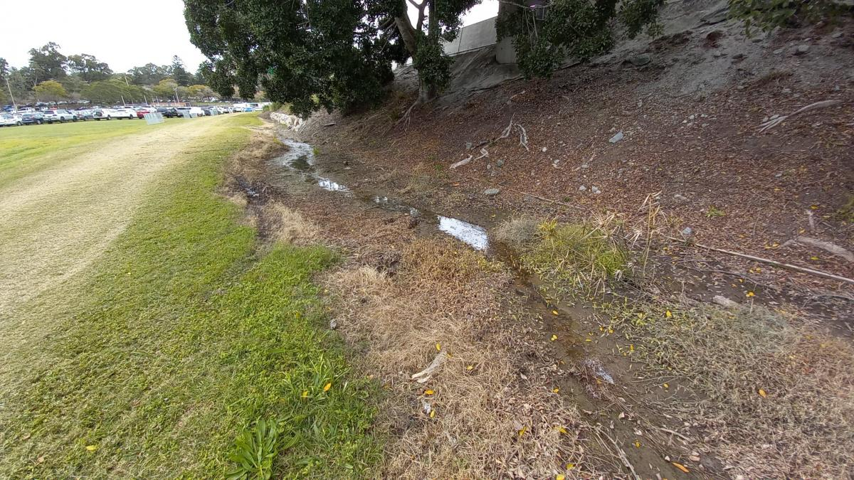
Figure 3: Victoria Park Cricket Nets parking area in late winter; recent rain shows the water’s natural flow through this part of Barrambin.
In other places, the prominence of storm drains evidences the heavy water flow through the area, redirected underground through civil engineering efforts to harness the land to human use and transportation. The Barrambin area also houses the Rail Corridor and the Inner-City Bypass, and is the site of part of an upcoming Cross-River Rail infrastructure Project; these structures cause water to pool in heavy rain, as seen in Figure 4.
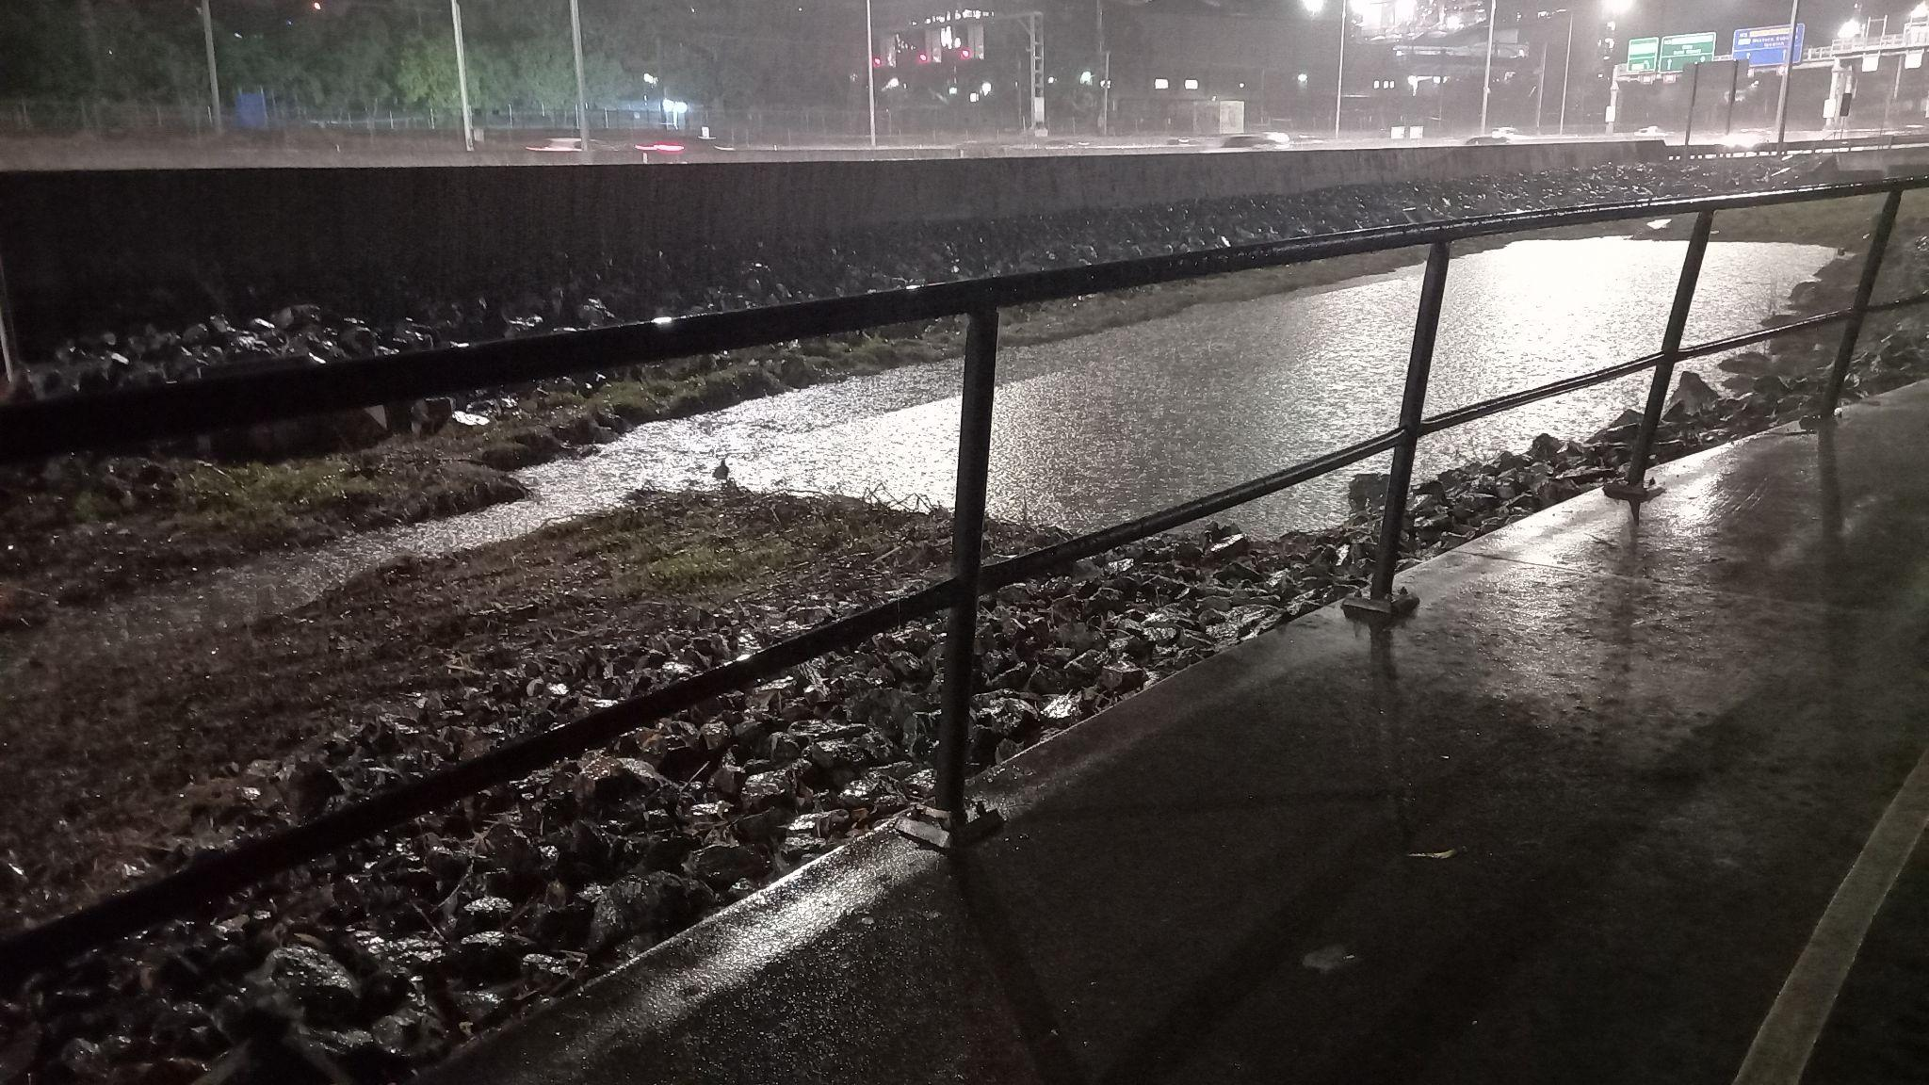
Figure 4: Waters of Barrambin re-emerge in heavy rain; here we see how water pools in spaces adjoining the Brisbane Inner City Bypass

Even this brief overview of the Barrambin area and its waterways and its entangled systems offers a glimpse of the overall character of the river as an entity with moods and combinant multiple heterogeneities. It is only in the western universalist perspective (Haraway 1991) that those who are considered less are given a single identity. As Star (1990) searingly observes, they are identified by others and not permitted their own multiple identities. This is not a facile distinction when it comes to understanding how we might design with the More-than-Human or seek to make kin as Salmond’s (2014) story of the plight of the Whanganui River attests. Even when the need to understand a multiplicitous More-than-Human entity, such as a river, is acknowledged through the law, the tensions created by the same classifications and production of boundaries mentioned earlier are deeply entrenched.

How do we understand Barrambin: Person vs Personhood
The need to consider rivers and waterways as More-than-Human and desperately in need of protection against pollution, degradation, and extinction has resulted in a number of projects where the legal status of personhood has been granted. Sometimes this is in conjunction with recognition of First Nations title and custodianship, if not recognition of Indigenous understandings of Country and waterways as living beings – as Rose says, "Country is a living entity with a yesterday, today and tomorrow, with a consciousness, and a will toward life” (1996, 7). The concept of “personhood” is a legal state which can be conferred on natural entities. Personhood is existential – a relational concept that pertains to the inherent state of being a person (e.g. biologically) and the context of being in the world (socio-culturally).
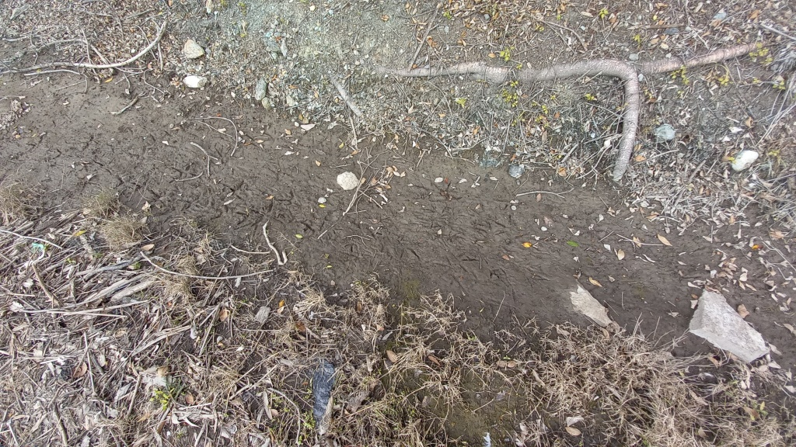
Figure 5: Close inspection of the latent waterways shows bird footprints – while the Barrambin waterways might not be visible to humans, our More-than-Human kin continue to engage with him/her/them.

The concept has legacies in a long-standing western nature/culture divide that produces profound paradox (Ingold 2000) because of the manner in which the two forms of definition might be seen to compete and clash. In this view, the biological aspects of being a person are recognised as being natural but are subordinated and dismissed in favour of the (specific) socio-cultural milieu of the rational mind. Contemporary personhood discussions tend to arise in the bailiwick of legal confrontations. It is more frequent to find contention and use of the concept of personhood as a legal status in cases where the rights of More-than-Human are argued with reference to personhood. This legal identification also has been extended to the environment and landscape in western law, for example, the Colorado River (Miller 2019). However, this continues to frame land as a “human-thing”, negating its identity as Country. In these cases, personhood is “granted” through the auspices of western legal systems – in contrast to the concept of being that Rose (1996) describes when she discusses the Australian Indigenous kinship with Country.
Personhood brings its own complexities back into the human world. It also then enables a disastrous feedback loop for what being allowed personhood might mean for an environmental entity. A number of cases have seen legal identification extended to the environment and landscape in western law. For example, the Magpie River in Canada was granted legal personhood by local authorities, and given nine rights, including the right to flow, the right to be safe from pollution, and, as a corollary of being a person, the right to sue. The problem is, as Miller (2019) suggests in his discussion of the case of the Colorado River, that the general and expansive right to exist, flourish, and naturally evolve that the law bestows must then be clearly demonstrated in a court of law as being transgressed, another form of constraint and boundary making.
This leads to further dilemmas when declaring personhood for a multiplicitous environmental entity such as a river, as Salmond (2014) observes in her discussion of the case of the Whanganui River on the west coast of the North Island of New Zealand. The Whanganui has been recognised as a living being and a human “face” has been established, chosen by the government and the Indigenous tribes as traditional custodians. Māori conceptualisations of the relationship between the river and the people are recognised, albeit with a number of caveats, including that the agreement cannot conflict with any existing private property rights and that use of any water from the river or its catchment tributaries is not pertinent to the agreement but is the bailiwick of a government body review process. In essence, the river as an entity is made separate in law from the water that makes up its existence. This is a clash between western law that recognises a “single” concept of river-ness, and Indigenous understandings of the river as a living whole entity that stretches from the mountains to the sea and includes not only tributaries but also its encompassing ecologies.
Another approach to creating relationships with the More-than-Human is to take an anthropomorphic approach and develop relationships through the attribution of human qualities, emotions, and actions to non-humans (Guthrie 1997). In connecting people with the More-than-Human, anthropomorphic narratives can be used to give a sense of kinship (Campbell 2009). Tam, Lee and Chao (2013) found that anthropomorphism increases people’s sense of connection and protectiveness of nature. Distinct from assigning personhood, which is a legal concept that isolates and defines specific aspects of More-than-Human entities, anthropomorphism develops a narrative around the subject (in our case, Barrambin) that allows people to understand its history and experiences contextualised via human experience.

The Barrambin project would not be the first to try to give a voice in this way to waterways. The Babbling Brook project (MIT Media Lab 2020) utlised sensors to collect real-time temperature and depth data from an unnamed creek in Massachusetts. Based on this data, the creek would “Tweet” messages on Twitter, for example, "I'm getting deeper. I'm at 4.4 inches. Time to cut back on the stormwater. lol.” (The Babbling Brook 2013). These tweets would assign the creek a human-like voice and consciousness, which communicated the health of the waterway.

From within the framework of western onto-epistemologies and the separation of nature and culture that often presents a paradox at its core (Ingold 2000), anthropomorphism is a narrative tool that brings the other, More-than-Human, into the purview of being human and, as such, carries with it complexities (Bruni, Perconti and Plebe 2018; Wynn 2004). A core criticism of anthropomorphism, particularly in scientific communities, is that it is subjective, and, particularly in the case of animals, may misattribute behaviours to different emotions or replace scientific exploration of animal behaviour (Wynne 2007). This may also be an issue for a complex multiplicitous More-than-Human like Barrambin. For example, while heavy rainfall might be described negatively on behalf of the Barrambin waters by humans (increased flooding, muddied creeks and damaged creek banks), it might have a realistic positive impact on the local flora and fauna and is indeed a critical part of the waters as a complex More-than-Human entity. There are also concerns that applying human-based behaviours to non-human entities leads to infantilising, where animals and pets are treated as children (Chaudhuri 2016; Lewis 2020; Nash 2020). While this type of (western) infantilising anthropomorphism may encourage people to take a caretaker role, it may trivialise the history of Barrambin. Barrambin also has a complex history and importance culturally, which would make anthropomorphism a complex process which requires a nuanced approach, particularly as the Australian Indigenous spiritual understanding of Barrambin (as Country), as a place and hence a living entity, is recognition that the More-than-Human are living entities that are deeply connected to other living entities. It is quite distinct to the western notion of anthropomorphism being more animist in the sense of acknowledging that multiplicitous More-than-Humans are alive and have spirit.

However, while Australian Indigenous commentators such as Mary Graham (2009) prioritise Place as being first and foremost and a priori to human experience and stories, Tuan (1977) tells us that place is shaped by a person's experience of it and layered with the experiences of others. By itself, place is just a location or “space”, but through the eyes of its inhabitants it can have many identities, such as home, and so becomes resonant with notions of Place as described by Graham. Any future anthropomorphic approaches for Barrambin would need to balance these complexities; however, reflections about the two concepts provide us with possible pathways to appropriate methodologies. Personhood and anthropomorphism are both a kind of “making persons”, as Haraway (2015) might observe, but one is an act of abstraction and rationalisation in order to fit into the law, whereas the other allows for subjectivities and narrative meaning and opens a door to relational understandings with both Place and its spiritual dimensions (Graham 2009). In particular the introduction of narrative allows for multiplicitous More-than-Human and allows for Place to “have” a spirit and so opens up possibilities of kinning.

Narrative inquiries: Connecting and Kinning through multiple walking stories
The concept of kinning offers us one pathway to connect with the More-than-Human in the context of the Barrambin waterways. Haraway suggests, “Kin-making is making persons, not necessarily as individuals or as humans” (2015, 161). Her distinction is important, as we discuss further on in this paper; it echoes commentary by Mary Graham (2009, 77) who admonishes the modernist trope of universal views and recommends a renewed focus on Place as, along with the traditional customs and stories for that Place, the determinant of being in the world:

Law and Place come into the world at the same time. With them come identity, obligation, kinship and marriage rules, or the Law of Relationships. Place is also a determinant of Being in the world; that is, Place is the informing quality or essence of the Mode of Being in the world.

Haraway’s “making” persons is a call for creating relationships with the non-human and Graham’s concept of identity and obligation formed through Place allows for making-kin and so provides us with insights for phase change More-than-Human methodologies. The act of kinning recognises that the More-than-Human are also storytellers, or perhaps story-makers (Turner and Taboada 2021), a distinction that announces collaboration and creation of spaces for shared active-imagination and moments of re-creation.
These insights invite consideration of narrative methodologies, those which recognise the fundamental power of stories. Narrative methodologies focus on subjective experiences and are often used in reflective evaluation when research goals are about insights and potential to reflect on commonalities (Polkinghorne 2007). Narrative research seeks to make statements about meaning in order to have something to say about the context, and so is also a relational approach (Connelly and Clandinin 1990; Graham 2009). Engaging in narrative research is about stories and storytelling and so is often found in contexts where the embodied and experiencing individual is of interest but for whatever reason they may not be in a position to articulate their agency or explain their experience (e.g. education and health situations). It is essentially place-based in the sense that its subjects are researched within their contexts (schools, homes, hospitals etc.) and the process of the research itself recognizes context and place (Trahar 2013). Ideally, a narrative research project is embodied through situating its process in time and place, thus drawing the researcher’s own subjectivity into its purview as well as allowing for other actors to contribute. This means that the outcomes are the stories and opportunities for insights and reflections (Polkinghorne 2007) and that we can focus on a single, unique, experience in order to understand that experience with reference to wider commonalities.

Walking With and Making Stories: Helping to let the waters speak
It becomes evident that the allocation of Personhood, while useful, is deeply problematic and doesn’t actually create a person or, more critically, allow the waters to speak. If we frame our understanding of the Barrambin waterways as being aspects of person, then we can use rich narrative approaches and create multiplicities and multiple layers of creative stories in order to offer an experience of waterways as kin. We can frame Barrambin and its waterways as a living entity with a will toward life (Rose 1996), even if the anthropomorphism is in the more “western” mode that Tuan (1977) describes where the stories make the Place (as opposed to Indigenous views where Place makes stories). This potentially allows us to make kin and become acquainted with Place through our own activity and bringing our own sensibilities from our experience with the waterways. These insights also scaffold a way in which we can engage the local community to participate in helping the waters of Barrambin to speak.
During 2023, we seek to engage the local Kelvin Grove Urban Village community with the new Barrambin/Victoria Parklands through creative walk-shops. Through these walk-shops, we aim to bring together members of the local community who live and work in Kelvin Grove to walk the traces of the former rivers and creeks of Barrambin and reflect on this experience through creative documentation methods such as mixed-media collage, audio, photography, storytelling, and sketching. This walk-shop will act as a participatory opportunity for the local community to engage, explore, and reflect on the long-held connections between Barrambin and its seen and unseen waterways. Walking has been commonly used as a method of sensory ethnography, physical embodiment, and the exploration of landscapes (Kusenbach 2018; Pink 2015; Weisskoeppel 2022). Practitioners detail the methodological format of a collaborative walk-shop as a way to "explore hidden tracks in the landscape”, which can transfer into "exploring colonial legacies and expanding public knowledge” (Weisskoeppel 2022, 47). We seek to utilise this act of collaborative walking to explore the traces of water along and through Barrambin.
Our walk-shops will become the basis for some further, iterative design work. Over the course of the session, participants will be asked to take part in a range of creative participatory activities, which may involve: listening to, and generating an understanding of, the complex histories of the site and context; following a map and walking around the Kelvin Grove Urban Village, tracing the pathways and the waterways; exploring the site and context through design-led activities such as sketching, collaborative designing, collecting and observing surroundings; providing their perspectives and experiences of the hidden waterways; co-designing, crafting and commenting on potential designs to “reveal” the hidden waterways; and being video and audio recorded and photographed during the co-design workshop session.
There is work yet to do but we are enticed by the sense of possibilities of this relational approach based on Barrambin as Place and its waterways as a person and kin. Narrative methodologies lend themselves to relational approaches and pivot us away from the established tenets of design practices, with their emphasis on the human, towards possibilities of designing with. Enabling participation of the community in the area means that further layers and even more multiplicity are possible in future stages, where we create artefacts that layer this understanding back into the physical world, responding to the conference theme of physical and temporal space. We cannot talk to the waterways, but through our own multiplicities we can walk with them and give the waters and the Place of their spirit a presence through narrative based relational methodologies.

Acknowledgements
The authors would like to acknowledge the Turrbal and Yuggera, as the First Nations custodians of the lands where QUT now stands, and of Barrambin. We pay respects to their Elders, lores, customs and creation spirits. We recognise that these lands have always been places of teaching, research, and learning and were never ceded. We would like to thank Jimmy Southwood for his guidance through Barrambin, and Kavita Gonsalves and Abbe Winter for their support in the project.

References
AKAMA, Y, LIGHT, A & KAMIHIRA, T 2020 ‘Expanding participation to design with more-than-human concerns’, 16th Participatory Design Conference, Manizales, Colombia, 15 June 2020, pp. 1-11.

BRISBANE CITY COUNCIL 2022, Flooding in Brisbane, Brisbane City Council, viewed 3 January 2023, <https://www.brisbane.qld.gov.au/community-and-safety/community-safety/disasters-and-emergencies/be-prepared/flooding-in-brisbane>.

BRUNI, D, PERCONTI, P & PLEBE, A 2018 ‘Anti-anthropomorphism and its limits’, Frontiers in Psychology, vol 9, p. 2205.

CAMPBELL, B 2009, ‘Fields of post-human kinship’, in J Edwards & C Salazar (eds), European kinship in the age of biotechnology, Berghahn Books, New York, pp. 162-178.

CHAUDHURi, U 2016, The Stage Lives of Animals: Zooeisis and performance, Routledge, New York.

CLANDININ, F & Connelly, D 1990 ‘Stories of experience and inquiry’, Educational Researcher, vol 19, no 5, pp. 2-14.

CLARKE, R, HEITLINGER, S, LIGHT, A, FORLANO, L, FOTH, M & DISALVO, C 2019, ‘More-than-human participation: Design for sustainable smart city futures’, Interactions, vol 26, no 3, pp. 60-63.

COOK, M, 2019, A river with a city problem: A history of Brisbane floods, University of Queensland Press, Brisbane, Australia.

COOK, MH 2018. 'A River with a City Problem, not a City with a River Problem: Brisbane and its Flood-Prone River’, Environment and History, vol 24, no 4, pp. 469-496.

DISALVO, C & LUKENS, J 2011, ‘Nonanthropocentrism and the nonhuman in design: possibilities for designing new forms of engagement with and through technology’, in M Foth, L Forlano, C Satchell & M Gibbs (eds), From social butterfly to engaged citizen: urban informatics, social media, ubiquitous computing, and mobile technology to support citizen engagement, MIT Press, Cambridge, MA, pp. 421-435.

DISALVO, C, SENGERS, P & BRYNJARSDÓTTIR, H 2010, ‘Mapping the landscape of sustainable HCI’, SIGCHI conference on human factors in computing systems, Atlanta, Georgia, USA, April 10 - 15, pp. 1975-1984.
Atlanta Georgia USA April 10 - 15, 2010

FORLANO, L 2016, ‘Decentering the human in the design of collaborative cities’, Design Issues, vol 32, no 3, pp. 42-54.

FORLANO, L 2017, ‘Posthumanism and design’, She Ji: The Journal of Design, Economics, and Innovation, vol 3, no 1, pp. 16-29.

FOTH, M, PAULOS, E, SATCHELL, C & DOURISH, P 2008, ‘Pervasive computing and environmental sustainability: Two conference workshops’, IEEE Pervasive Computing, vol 8, no 1, pp. 78-81.

GIACCARDI, E & REDSTRÖM, J 2020, ‘Technology and more-than-human design’, Design Issues, vol 36, no 4, pp. 33-44.

GRAHAM, M 2009, ‘Understanding human agency in terms of place: A proposed Aboriginal research methodology’, PAN: Philosophy Activism Nature, vol 6, pp 71-78.

GUTHRIE, SE 1997, ‘Anthropomorphism: A definition and a theory’, In RW Mitchell, NS Thompson & HL Miles (eds), Anthropomorphism, anecdotes, and animals, State University of New York Press, Albany, NY.

HARAWAY, D 2015, ‘Anthropocene, capitalocene, plantationocene, chthulucene: Making kin’, Environmental Humanities, vol 6, no 1, pp. 159-165.

HARAWAY, DJ 1991, Simians, cyborgs, and women: The reinvention of nature. Routledge, New York, NY.

HARAWAY, DJ 2016, Staying with the trouble: Making kin in the Chthulucene, Duke University Press, Durham, UK.

INGOLD, T 2000, The Perception of the Environment. Essays in Livelihood, Dwelling and Skill, Routledge, New York.

INGOLD, T 2005, ‘Epilogue: Towards a politics of dwelling’, Conservation and Society, vol 3, no 2, pp. 501-508.

KLAEBE, H 2006, Sharing stories: a social history of Kelvin Grove Urban Village, Focus Publishing, Bondi Junction, NSW.

KUSENBACH, M 2018, ‘Go-alongs’, in U Flick (ed) The SAGE handbook of qualitative data collection, SAGE, London, UK, pp. 344-361.

LEWIS, A 2020, ‘Infantilizing companion animals through attachment theory: why shift to behavioral ecology-based paradigms for welfare’, Society & Animals, vol 1, pp. 1-18.

MILLER, M 2019, ‘Environmental Personhood and Standing for Nature: Examining the Colorado River case’, The University of New Hampshire Law Review, vol 17, no 2, pp. 355-377.

MIT MEDIA LAB 2020, The Babbling Brook, MIT, viewed 3rd of January 2023, <https://www.media.mit.edu/projects/the-babbling-brook/overview/>.

MORRIS, J & RURU, J 2010, ‘Giving Voice to Rivers: Legal Personality as a Vehicle for Recognising Indigenous Peoples' Relationships to Water?’, Australian Indigenous Law Review, vol 14, no 2, pp. 49-62.

NASH, C 2020, ‘Kinship of Different Kinds: Horses and People in Iceland’, Humanimalia, vol 12, no 1, pp. 118-144.

PAULOS, E, FOTH, M, SATCHELL, C, KIM, Y, DOURISH, P & CHOI, H-J 2008, ‘Ubiquitous sustainability: Citizen science and activism’, Association for Computing Machinery (ACM), United States of America

PINK, S 2015, Doing Sensory Ethnography, 2nd edn, SAGE Publications, London, UK.

POLKINGHORNE, DE 2007, ‘Validity issues in narrative research’, Qualitative Inquiry, vol 13, no 4, pp. 471-486.

ROSE, DB 1996, ‘Nourishing terrains: Australian Aboriginal views of landscape and wilderness’, Australian Heritage Commission,

SALMOND, A 2014, ‘Tears of Rangi: Water, power, and people in New Zealand’, HAU: Journal of Ethnographic Theory, vol 4, no 3, pp. 285-309.

SEGATO, RL & MCGLAZER, R 2018, ‘A manifesto in four themes’, Critical Times, vol 1, no 1, pp. 198-211.

STAR, SL 1990, ‘Power, technology and the phenomenology of conventions: on being allergic to onions’, The Sociological Review, vol 38, no 1, pp. 26-56.

TAM, K-P, LEE, S-L & CHAO, MM 2013, ‘Saving Mr. Nature: Anthropomorphism enhances connectedness to and protectiveness toward nature’, Journal of Experimental Social Psychology, vol 49, no 3, pp. 514-521.

THE BABBLING BROOK 2013, ‘I'm getting deeper. I'm at 4.4 inches. Time to cut back on the stormwater. Lol’, edited by @DaBabblingBrook: Twitter, viewed 4 January 2023, <https://twitter.com/DaBabblingBrook/status/411830904500535296>.

TOMITSCH, M, FREDERICKS, J, VO, D, FRAWLEY, J & FOTH, M 2021, ‘Non-Human Personas: Including Nature in the Participatory Design of Smart Cities’, Interaction Design and Architecture(s), vol 50, no 50, pp. 102-130.

TOSO, T, SPOONER-LOCKYER, K & HETHERINGTON, K 2020, ‘Walking with a ghost river: Unsettling place in the Anthropocene’, Anthropocenes–Human, Inhuman, Posthuman, vol 1, no 1, pp. 1-13.

TRAHAR, S 2013, Contextualising narrative inquiry: Developing methodological approaches for local contexts: Routledge, New York, NY.

TUAN, YI, 1977, Space and place: The perspective of experience. University of Minnesota Press: Minneapolis, MN

TUHIWAI SMITH, L 1999, Decolonizing methodologies: Research and Indigenous peoples, Zed Books, London, UK.

TURNER, J & TABOADA, M 2021, ‘Story-making: Re-imagining possible futures through collaborative world-building approaches’, in R Leitão, Men, I, Noel, L-A, Lima, J & Meninato, T (eds.) Proceedings of Pivot 2021: Dismantling / Reassembling: Tools for alternative futures, Design Research Society (UK), London, UK, pp. 417-428.

VERRAN, H 1998, ‘Re-imagining land ownership in Australia’, Postcolonial Studies: Culture, Politics, Economy, vol 1, no 2, pp. 237-254.

WADE, H 1844, Map of the Environs of Brisbane Town, Situate in the Country of Stanley, Surveyor General’s Department, Queensland State Archives, viewed 3 January 2023, <https://www.archivessearch.qld.gov.au/items/ITM714303>.

WEISSKOEPPEL, C 2022, ‘Dealing with Postcolonial Pasts to Envision a Respectful Future: On the Format of Collaborative Walk-Shops’, Collaborative Anthropologies, vol 14, no 2, pp. 47-62.

WYNN, CDL 2004, ‘The perils of anthropomorphsim’, Nature, vol 428, no 6983, p. 606.

WYNNE, CDL 2007, ‘What are animals? Why anthropomorphism is still not a scientific approach to behavior’, Comparative Cognition & Behavior Reviews, vol 2, pp. 125-135.

YAMAZAKI, D, IKESHIMA, D, TAWATARI, R, YAMAGUCHI, T, O'LOUGHLIN, F, NEAL, JC, SAMPSON, CC, KANAE, S & BATES, PD 2017, ‘A high‐accuracy map of global terrain elevations’, Geophysical Research Letters, vol 44, no 11, pp. 5844-5853.

